Holy Days at Home

Joyful Simple Faithful
www.thesecondjoyfulmystery.wordpress.com

St. Kateri Tekakwitha
July 14th

Hear, O daughter, and see; turn your ear, forget your people and your father’ house. So shall the king desire your beauty; for he is your lord, and you must worship him.
-Psalm 45:11-12

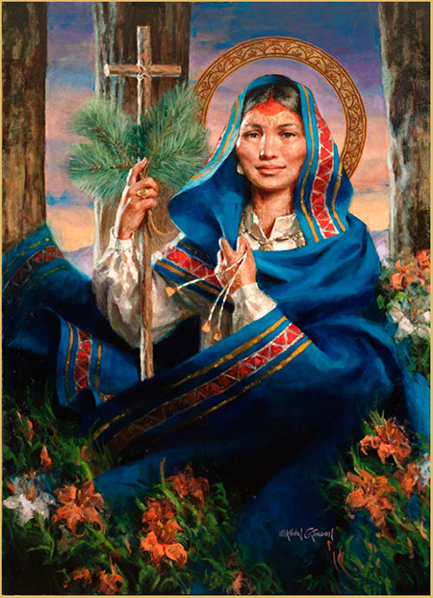
by Kevin Gordon. www.saint-kateri.com

Story and Scripture
I recommend getting a copy of one of the many children’s books on St. Kateri Tekakwitha. Here are a couple suggestions:
- Kateri of the Mohawks Storybook published by the National Kateri Center. It’s a bit wordy for littler ones, but good for the 1-5 grade levels. Or can be broken up and read over the course of the week.
- Blessed Kateri Tekakwitha: The Lily of the Mohawks by Father Lovasik, S.V.D. Published by St. Joseph Kids’ Books.
- Kateri Tekakwitha: Model of Bravery by Barbara Yoffie
There are truly just so many books on this amazing saint’s life!

If you can’t get your hands on a copy of a storybook become familiar with her story so you can tell it to your children. The National Kateri Center website is a good place to start. Or a simple web search will bring up many good reading choices. The blog post for the preparation day will have a simple story as well!

Then you can read Psalm 45:11-12 and for older children refer back to St. Kateri’s life and discuss how this Psalm mirrors her devotion.

Craft
St. Kateri’s Wooden Crosses
St. Kateri was known to fasten crosses from twigs as she walked the woods to mark her way with Christ. This simple craft is one that the children will enjoy, and is an activity they can remember St. Kateri by any time they’re out in nature!

Materials: Twigs, twine or string
Instructions: Hold two twigs in the shape of a cross with one hand. With the other take a length of twine or string, beginning at one end wrap the string around one angle of the crossing point of the two twigs three times. Be sure to leave a length to from the knot from at the end. Then switch angles and wrap three times the other way. Tie two ends in a knot and tuck in remainder or snip the ends. This can also be done with a long blade of grass or soft bark.

St. Kateri Coloring Page

Prayer
O God, who desired the Virgin St. Kateri Tekakwitha
to flower among Native Americans
in a life of innocence,
grant, through her intercession,
that when all are gathered into your Church
from every nation, tribe and tongue,
they may magnify you
in a single canticle of praise.
Through our Lord Jesus Christ, your Son,
who lives and reigns with you in the unity of the Holy Spirit,
one God, for ever and ever.
From The Liturgy of the Hours on the feast of St. Kateri Tekakwitha

St. Kateri, patron saint of the environment, pray for us!

Treat
One of the staples of the Mohawk diet was corn. For this celebration you can enjoy a corn snack! Try popcorn from a bag or popper! Or for a hands-on activity try these Corn Bread recipes:
- Blueberry Maple Cornbread Muffins This recipe reminds me of some of the favorite flavors of upstate New York, St. Kateri’s birthplace
- Ina Garten’s Sour Cream Cornbread recipe is one of my all-time favorites. It’s delicious spread with butter and jam!

