Holy Days at Home

Joyful Simple Faithful
www.thesecondjoyfulmystery.wordpress.com

Our Lady of Mt. Carmel
July 16th



Story and Scripture
Optional: Show your children a map of Israel and point out some of the places Jesus traveled and lived. Point out Mt. Carmel (in the northwestern section of Israel adjacent to the sea).
Story: Tell or read the story of the Carmelites and the Brown Scapular using one of these resources or your own!
- Saints For Kids from Loyola Press: a succinct explanation of the history of the order as well as an explanation the brown scapular.
- A short piece I composed in honor of the day can be found on the Prepare! post for this feast day.

Scripture: For a scripture component read the Magnificat together (Luke 1:46-55). This passage is the responsorial Psalm during the Mass of the day!

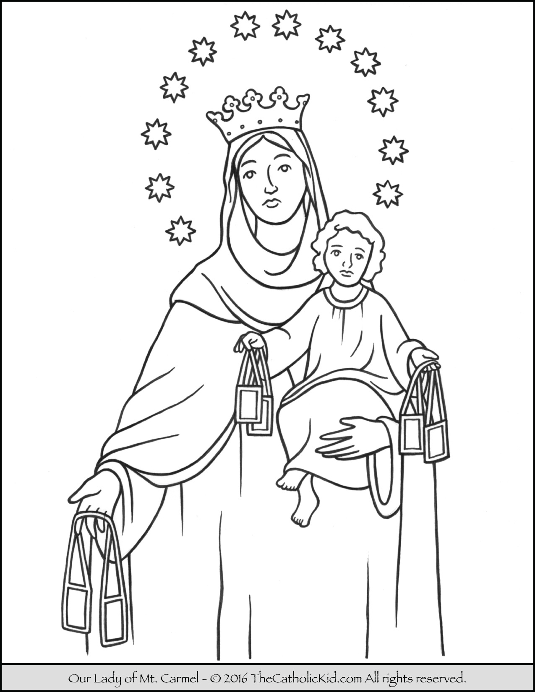
Coloring Page
You can download and print this coloring page from TheCatholicKid.com:

Craft
This day’s craft is a wall hanging version of a brown scapular. I found this craft on Catholic Inspired.

Materials:
Brown Paper or paper colored brown; Printed images for the Brown Scapular from Catholic Inspired; Scissors; Glue; String, yarn or twine
Instructions:
- Cut out images. Cut brown paper into two rectangles a little larger than the images.
- Glue the images onto the brown pieces of paper
- Cut the string or yarn into two equal pieces.
- Attach one end of each string to the top corners of the first brown rectangle. Attach the other ends of the pieces of string to the top corners of the other brown rectangle so that the images face out when place back to back. Voila!
Prayer

There are two options for today’s prayer. One is the Prayer of St. Simon Stock:

O, beautiful Flower of Carmel,
most fruitful vine,
Splendor of Heaven,
holy and singular,
Who brought forth the Son of God,
still ever remaining a Pure Virgin,
assist me in this necessity.
O, Star of the Sea,
help and protect me.
Show me that Thou art my Mother.

O, Mary, conceived without sin,
Pray for us who have recourse to Thee.

Mother and Ornament of Carmel,
pray for us.

Virgin, Flower of Carmel,
pray for us.

Patroness of all who wear the Scapular,
pray for us.

Hope of all who die wearing the Scapular,
pray for us.

St. Joseph, Friend of the Sacred Heart,
pray for us.

St. Joseph, Chaste Spouse of Mary,
pray for us.

St. Joseph, our Patron,
pray for us.

O, Sweet Heart of Mary,
be our Salvation.

The other is, as usual, the prayer of the day from the Liturgy of the Hours

Father,
may the prayers of the Virgin Mary protect us
and help us to reach Christ her Son,
who lives and reigns with you and the Holy Spirit,
one God, for ever and ever. Amen.

The Treat!
Caramel Ice Cream Mountains (i.e. Caramel Sundaes)
For the sundaes pile up some of your favorite ice cream and drizzle with your favorite caramel sauce. Bon Appetit!
For a homemade caramel sauce try this Salted Caramel Sauce. It's delicious! You can trust me on that.
You can also enjoy caramel candies or head to your favorite ice cream shop to share a sundae!

