Holy Days at Home

Joyful Simple Faithful
www.thesecondjoyfulmystery.wordpress.com

Sts. Joachim and Anne
July 26th


Patron saints of Grandparents

Today’s celebration is a perfect time to invite the grandparents over to participate!

Story and Scripture

Story: Loyola Press’ Saints for Kids feature is a great resource for today. The site provides a short, easy to understand writing on the grandparents of Jesus. Go to Loyla Press to print or read from the screen for today’s introduction of the saints.

Scripture: Today’s scripture passage is actually taken from the Liturgy of the Hours responsory for this feast day’s prayers. It is in reference to Luke 2: 37-38 and Luke 7:16:
They worshipped God day and night
in fasting and in prayer.
- They looked forward to the deliverance of Israel.
They prayed that God would come to save his people
- They looked forward to the deliverance of Israel.

It’s a nice little piece to say aloud or read together if you have readers in your house.

Coloring Page
I’ve got two coloring pages for you today. One with lots of white space (Super Coloring) and another more detailed (from Catholic Playground). Please use the links from the blog to get the full size images!
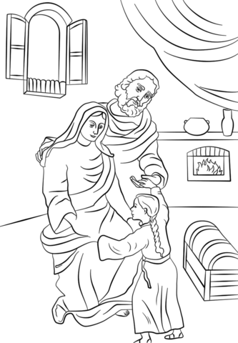

Craft
For today’s craft I thought it’d be fun to focus on the Sts. Joachim and Anne as the grandparents of Jesus and as the patrons of Grandparents by making photo collages of pictures of your children’s grandparents.

This one may take a little adult preparation or shopping to get ready. And you can really have fun with it! Decorate the collages however you like, with whatever you have on hand. The directions I present below are for a collage including pictures of Sts. Joachim and Anne printed from the computer. You’ll also need photos of the grandparents in your lives.

If the collage is too hands-on for your family right now, consider flipping through pictures of all the grandparents and telling the stories that go along with them.

Materials: cardboard, poster board, an old folder, something sturdy!; paint, glue, tissue or color paper cut into small squares; printed images of Sts. Anne and Joachim or holy cards of them, photographs of your grandparents

Instructions:
- Begin by allowing the child to paint the cardboard/posterboard/sturdy paper however he wishes.
- Before the paint dries help your children press on squares of tissue paper to make a collage of color (it may look like stained glass window!). If the paint begins to dry use a little glue to affix the squares.
- Affix any images of Sts. Anne and Joachim and the grandparents. Let dry.
- Dilute your glue in a cup or bowl with a little bit of water so that it’s thin enough to spread on, about 2:1 glue to water. Once your collage is dry you or your child can paint on a thin coat of the glue-water mixture. Let dry again.
- Hang near your prayer space or in your childs room as a reminder to pray to Sts. Joachim and Anne for their grandparents!

Prayer

O Lord, God of our Fathers,
who bestowed on Saints Joachim and Anne this grace,
that of them should be born the Mother of your incarnate Son,
grant, through the prayers of both,
that we may attain the salvation
you have promised to your people.
Through our Lord Jesus Christ, your Son,
who lives and reigns with you in the unity of the Holy Spirit,
one God, for ever and ever

Treat

I’m including two of my own grandparent’s favorite desserts as today’s options. I’d encourage you, though, to think back to what your own grandparents enjoyed as a treat or what your parents or in-laws or grandparents enjoy as their favorite dessert. Present the treat as a grandparent’s favorite in honor of the grandparents of Jesus!

For the homemade option:
Granny Buras’ Chocolate Pie
Ingredients
- 1 package chocolate pudding (non-instant)
- 2 eggs, beaten
- 1 cup sugar
- 1 cup evaporated milk
- ½ cup water
- 1 tsp vanilla
- one pie crust (store bought or homemade).

- Bake pie crust as indicated. Let cool.
- Mix all ingredients in saucepan on stove. Cook until thick over low heat, stirring constantly.
- Pour into prepared pie crust.
- Refrigerate until firm.
- Serve with whipped cream.

For the store-bought option:

